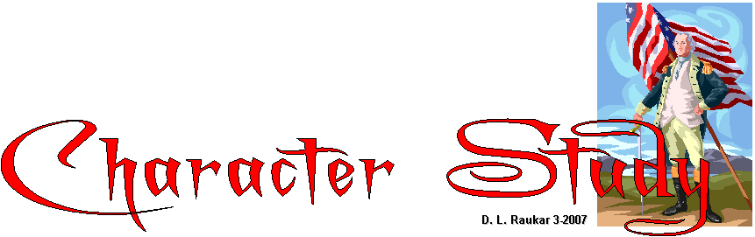Learn more about some our most famous Americans by checking out the links below. To save an image, point to the picture, Right click "Save Picture as" Next to file name, type a: for disk type s: for student folder and f: for flash drive (may be different at home). Press Enter. For extra help, go to the Computer Tips on my main page and click "Save your work" Photostory presentation.
Colonial Hall: information about the Founding Fathers
American Presidents-Life Portraits: official presidential site
GEORGE WASHINGTON: our first president and general in the army.
George Washington-Life Portraits: good source of information and pictures
George Washington: White House
Wikipedia: George Washington : Click this picture to get a larger version.
George Washington Photo Gallery: Click the picture you want to get a larger version before saving it.
Indian Child: George Washington
George and Martha Washington: a great photo gallery
George Washington: Just for fun-online coloring page
George Washington: emints site- has some very good links and a video.
George Washington Mount Vernon estates: has period music, too

THOMAS PAINE: writer of “Common Sense”
Thomas Paine: Wikipedia: You may click his picture to get a larger version.
Thomas Paine: Common Sense – his “latest edition”
From Revolution to Reconstruction: biography of Thomas Paine
Thomas Paine: this official site includes pictures of his monuments, museum, cottage and biographies. (after looking at pictures, click on “Life and Works of Thomas Paine” link at top of page.
Thomas Paine Quotations: This site will give you quotes from Thomas Paine.

JOHN HANCOCK: famous American whose signature on the Declaration of Independence is most recognizable.
John Hancock and U.S. History: has biographies of all the signers of the Declaration of Independence.
John Hancock: Wikipedia: This site has a good color photo of him, too. Click the picture to get a larger version.
John Hancock-America’s Story: find out why a signature is a “John Hancock”.
American Revolution Home Page : John Hancock biography, pictures and period music.
John Hancock Portrait Page: this early Americana page includes many portraits of famous Americans.

THOMAS JEFFERSON: Third President of the United States from 1801-1809
Thomas Jefferson: This is the official White House Site
Thomas Jefferson-Wikipedia: Good resource and good portrait-click it to get a larger version.
Thomas Jefferson's Monticello: His official home site for Monticello.
Thomas Jefferson-Ame's Lab: Good outline of biographical information and portrait.
University of Virginia Digital Archive-Thomas Jefferson: Check out this site.
Library of Congress-Thomas Jefferson: official site
PBS-Thomas Jefferson Online: a great resource!
Library of Congress Exhibition-Thomas Jefferson: another good resource

JOHN ADAMS
John Adams-White House: This official White House page includes portraits and a biography.
John Adams-Wikipedia: another very good portrait-click the picture to get a larger image. Good source of information as well.
Portrait of John Adams: another early American page.
Colonial Hall: good biography and portrait of John Adams; this site also includes information about the founding fathers.
US History and John Adams: more good information
John Adams-American Presidents: This site is devoted to information about all U.S. presidents.

RICHARD HENRY LEE: Founding father and signer of the Declaration of Independence.
Richard Henry Lee: Colonial America
Richard Henry Lee-Signers of the Declaration of Independence
Richard Henry Lee-Wikipedia: click on portrait to get a larger version.
Biographical Directory of Congress: Richard Henry Lee
Richard Henry Lee biography: from Stratford Hall, tells a little about his personality and his contributions.

